INCOME TAX DEPARTMENT OF INDIA

PROJECT OF CSE326

COMPUTER SCIENCE AND ENGINEERING

Submitted by:
NAME-Abhinay Yadav (12211852)
NAME-Abhishek Kumar (12209346)

Submitted to:
MISS ISHA



LOVELY PROFESSIONAL UNIVERSITY
PUNJAB

December 2022

PROJECT REPORT

1.INTRODUCTION TO THE PROJECT
This project named income tax department website .
This project is made in three-part first is main website , second is login page,and the third is forget the password.

2.FEATURES
This website helps us to do many tasks as the original website can do.through this website we can login to the income tax department also we can register as a new user ,if anyone forgotten their password they can reset it easily.
This website has different links like link to aadhar card,pan card etc
This website helps us to know the latest notification of the income tax website.
Through this website we can also read the FAQ problems through the link given
There is a quick links provided in the website through which we can do the task
like ITR status
In this website also there is a news and update section through which we can
read the daily basis news coming from the income tax department.
There is a section for question where we can raise our question to the
Department.There is section for solved questions where user can see their
answer regarding to their asked question.There is navigation bar in the website
in which user can contact to the owner.
3.FLOWCHART
1.HTML
2.CSS
3.Use of certain links and images
4.SCREENSHOT
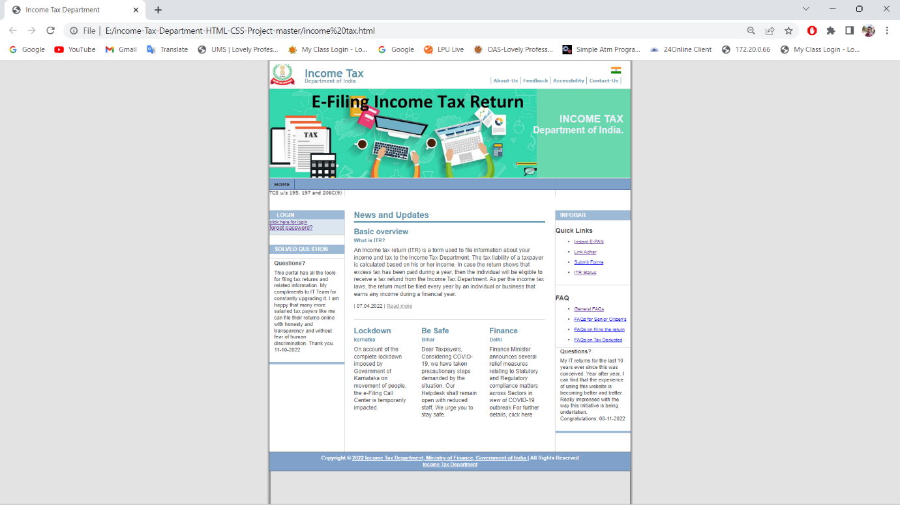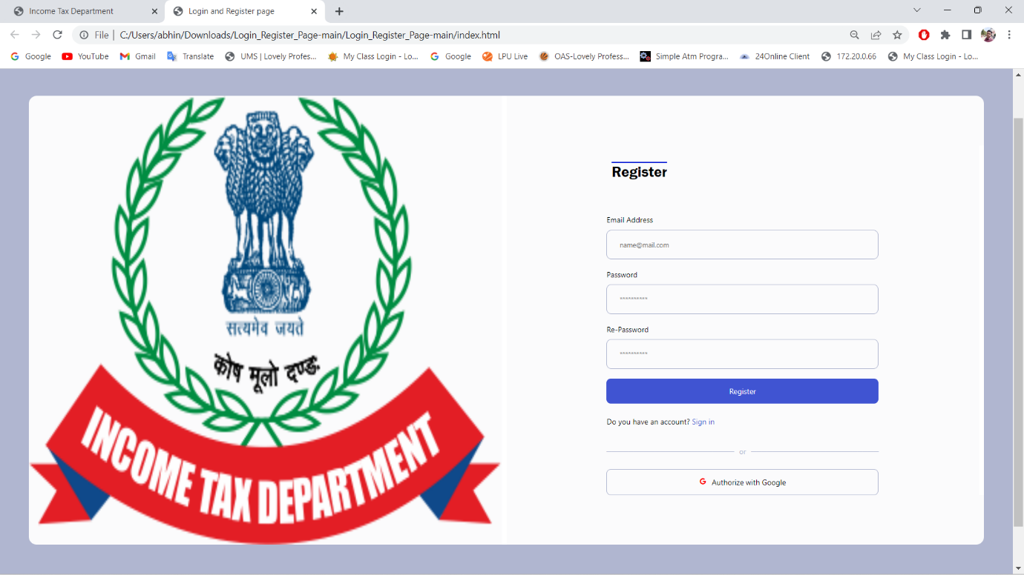

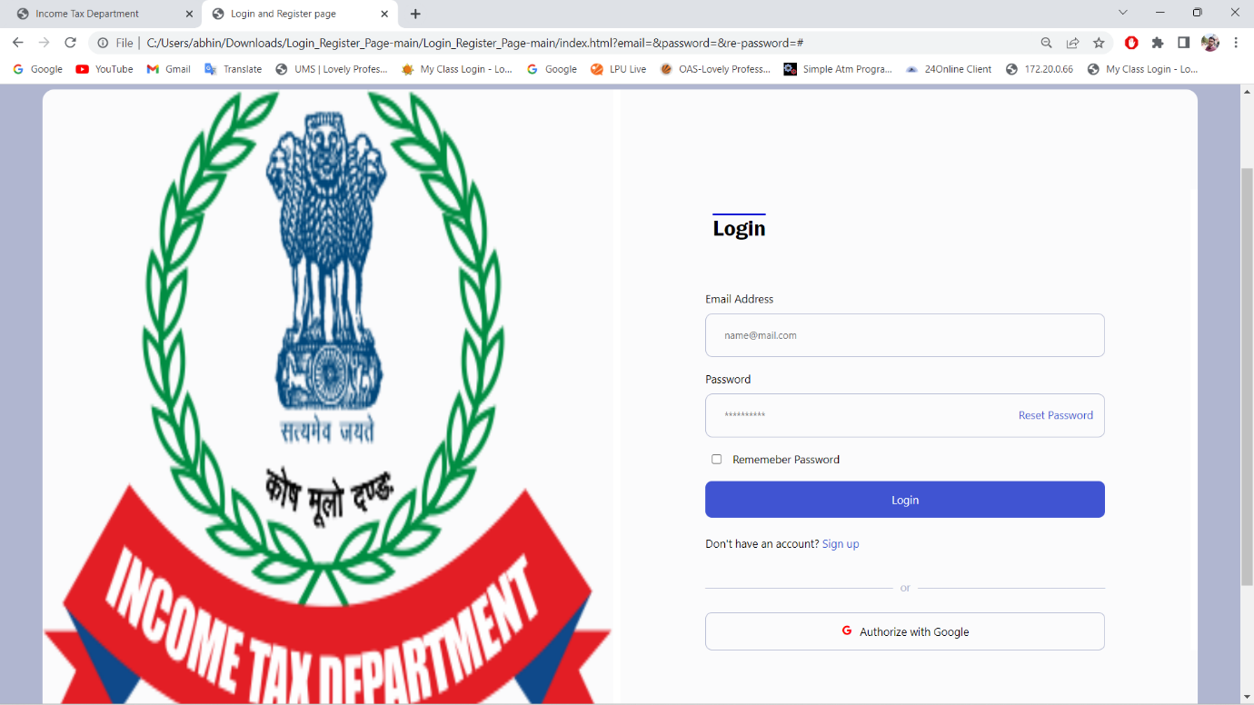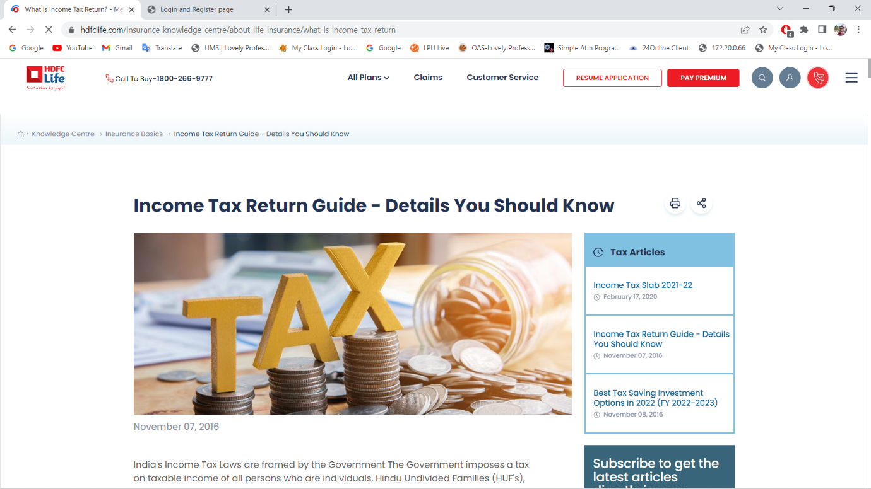

5.CODE
1.main file code:
<!DOCTYPE html >
<html>
<head>
<title>Income Tax Department</title>
<meta http-equiv="content-type" content="text/html; charset=iso-8859-1" />
<link rel="stylesheet" type="text/css" media="screen,projection" href="css/style_screen.css" />
</head>
<body>
<div class="page-container-1">
<div class="navflag-container">
<div class="navflag">
<ul>
<li><a href="#"><img class="img-navflag" src="img/india flag.png" alt="flag of india" /></a></li>
</ul>
</div>
</div>
<div class="nav1-container">
<div class="nav1">
<ul>
<li><a href="#">About-Us</a></li>
<li><a href="#">Feedback</a></li>
<li><a href="#">Accessbility</a></li>
<li><a href="#">Contact-Us</a></li>
</ul>
</div>
</div>
<div class="site-name">
<p class="title"><a href="https://www.incometaxindia.gov.in/" target="_blank">Income Tax</a></p>
<p class="subtitle"><a href="https://www.incometaxindia.gov.in/" target="_blank">Department of India</a></p>
</div>
<div class="site-slogan-container">
<div class="site-slogan">
<p class="title">INCOME TAX</p>
<p class="subtitle">Department of India.</p>
</div>
</div>
<div><img class="img-header" src="img/header.png" alt=""/></div>
<div class="nav2">
<ul>
<li><a href="https://www.incometax.gov.in/iec/foportal/" class="selected">Home</a></li>
</ul>
<marquee>Order u/s 119 of The Income Tax Act, 1961 on issue of certificates for lower rate/nil deduction/collection of TDS or TCS u/s 195, 197 and 206C(9)</marquee>

</div>
<div class="buffer"></div>
<div class="nav3">
<ul>
<li class="title">Login</li>
<div class="login">
<a href="C:\Users\abhin\Downloads\Login_Register_Page-main\Login_Register_Page-main\index.html" target="_blank">click here for login</a>
<p><a href="C:\Users\abhin\Downloads\Login_Register_Page-main\Login_Register_Page-main\index.html" class="forgot" target="_blank">forgot password?</a></p>
</div>
<div class="shadow"></div>
</ul>
<p class="sidebar-maintitle">Solved Question</p>

<p class="sidebar-title-noshade">Questions?</p>
<div class="sidebar-txtbox-noshade">
<p>This portal has all the tools for filing tax returns and related information. My compliments to IT Team for constantly upgrading it. I am happy that many more salaried tax payers like me can file their returns online with honesty and transparency and without fear of human discrimination. Thank you. 11-10-2022</p>
</div>
<p class="sidebar-maintitle"></p>
<div class="sidebar-txtbox-noshade">
<p></p>
</div>
</div>
<div class="content1">
<div class="content1-pagetitle">News and Updates</div>
<div class="content1-container line-box">
<div class="content1-container-1col">
<p class="content-title-noshade-size3">Basic overview</p>
<p class="content-subtitle-noshade-size1">What is ITR?</p>
<div class="content-txtbox-noshade">
<p>An Income tax return (ITR) is a form used to file information about your income and tax to the Income Tax Department. The tax liability of a taxpayer is calculated based on his or her income. In case the return shows that excess tax has been paid during a year, then the individual will be eligible to receive a tax refund from the Income Tax Department.

As per the income tax laws, the return must be filed every year by an individual or business that earns any income during a financial year.</p>
<p class="readmore">| 07.04.2022 | <a href="https://www.hdfclife.com/insurance-knowledge-centre/about-life-insurance/what-is-income-tax-return">Read more</a></p>
</div>
</div>
</div>
<div class="content1-container">
<div class="content1-container-3col-left">
<p class="content-title-noshade-size3">Lockdown</p>
<p class="content-subtitle-noshade-size1">karnatka</p>
<div class="content-txtbox-noshade">
<p>On account of the complete lockdown imposed by Government of Karnataka on movement of people, the e-Filing Call Center is temporarily impacted.</p>
</div>
</div>
<div class="content1-container-3col-middle">
<p class="content-title-noshade-size3">Be Safe</p>
<p class="content-subtitle-noshade-size1">Bihar</p>
<div class="content-txtbox-noshade">
<p>Dear Taxpayers, Considering COVID-19, we have taken precautionary steps demanded by the situation. Our Helpdesk shall remain open with reduced staff, We urge you to stay safe.</p>
</div>
</div>
<div class="content1-container-3col-right">
<p class="content-title-noshade-size3">Finance</p>
<p class="content-subtitle-noshade-size1">Delhi</p>
<div class="content-txtbox-noshade">
<p>Finance Minister announces several relief measures relating to Statutory and Regulatory compliance matters across Sectors in view of COVID-19 outbreak For further details, click here
</p>
</div>
</div>
</div>

</div>
<div class="sidebar">
<p class="sidebar-maintitle">Infobar</p>
<h3 class="title">Quick Links</h3>
<div id="hpage_quicklinks">
<ul class="clear">
<li><a href="https://eportal.incometax.gov.in/iec/foservices/#/pre-login/instant-e-pan" target="_blank">Instant E-PAN</a></li> <br>
<li><a href="https://eportal.incometax.gov.in/iec/foservices/#/pre-login/bl-link-aadhaar" target="_blank">Link Adhar</a></li> <br>
<li><a href="#">Submit Forms</a></li> <br>
<li><a href="https://eportal.incometax.gov.in/iec/foservices/#/pre-login/itrStatus" target="_blank">ITR Status</a></li> <br>
</ul>
</div>
<p class="sidebar-title-noshade"></p>
<h3 class="title">FAQ</h3>
<div id="hpage_quicklinks">
<ul class="clear">
<li><a href="https://www.incometax.gov.in/iec/foportal//help/all-topics/e-filing-services/filing-your-return#faqs-on-ais-(annual-information-statement)" target="_blank">General FAQs</a></li> <br>
<li><a href="#">FAQs for Senior Citizen's</a></li> <br>
<li><a href="#">FAQs on filing the return</a></li> <br>
<li><a href="#">FAQs on Tax Deducted</a></li>
</ul>
</div>
<p class="sidebar-title-noshade">Questions?</p>
<div class="sidebar-txtbox-noshade">
<p>My IT returns for the last 10 years ever since this was conceived. Year after year, I can find that the experience of using this website is becoming better and better. Really impressed with the way this initiative is being undertaken. Congratulations. 08-11-2022</p>
</div>
<p class="sidebar-maintitle"></p>
<div class="sidebar-txtbox-noshade">
<p></p>
</div>
</div>
<div class="footer">
<p><b> Copyright &copy; <a href="https://www.incometax.gov.in/iec/foportal/" target="_blank">2022 Income Tax Department, Ministry of Finance, Government of India </a>| All Rights Reserved</b></p>
<p><a href="https://www.incometaxindia.gov.in/" target="_blank">Income Tax Department</a></p>
</div>
</div>
</body>
</html>

2.login and register page code
<!DOCTYPE html>
<html lang="en">

<head>
<meta charset="UTF-8">
<meta http-equiv="X-UA-Compatible" content="IE=edge">
<meta name="viewport" content="width=device-width, initial-scale=1.0">
<title>Login and Register page</title>
<!-- CSS -->
<link rel="stylesheet" href="style.css">
<!-- Remix Icons -->
<link href="https://cdn.jsdelivr.net/npm/remixicon@2.5.0/fonts/remixicon.css" rel="stylesheet">
</head>

<body>
<div class="container">
<div class="row">
<img src="C:\Users\abhin\Downloads\llllll.png" alt="img" class="img">
</div>
<div class="row">
<form action="#" class="form active" id="login">
<h2>Login</h2>
<label for="email">Email Address</label>
<div class="pass-reset" onclick="activeInput(this)">
<input type="email" name="email" class="email" id="emailInput" placeholder="name@mail.com">
</div>
<label for="password">Password</label>
<div class="pass-reset" onclick="activeInput(this)">
<input type="password" class="password" name="password" id="password" placeholder="**********">
<a href="#" class="reset-password">Reset Password</a>
</div>
<div class="pass-reset remember-box">
<input type="checkbox" name="remember" class="remember" id="remember"><span class="remember-text">Rememeber Password</span>
</div>
<button class="btn btn-login">Login</button>
<p>Don't have an account? <a onclick="changeToRegister()" id="changeToRegister">Sign up</a></p>
<p class="or">or</p>
<button class="btn btn-gogle-auth"><i class="google ri-google-fill"></i>Authorize with Google</button>
</form>
<form action="#" class="form" id="register">
<h2>Register</h2>
<label for="email">Email Address</label>
<div class="pass-reset" onclick="activeInput(this)">
<input type="email" name="email" class="email" id="emailInput" placeholder="name@mail.com">
</div>
<label for="password">Password</label>
<div class="pass-reset" onclick="activeInput(this)">
<input type="password" class="password" name="password" id="password" placeholder="**********">
</div>
<label for="re-password">Re-Password</label>
<div class="pass-reset" onclick="activeInput(this)">
<input type="password" class="password" name="re-password" id="re-password" placeholder="**********">
</div>
<button class="btn btn-login">Register</button>
<p>Do you have an account? <a onclick="changeToLogin()" id="chnageToLogin">Sign in</a></p>
<p class="or">or</p>
<button class="btn btn-gogle-auth"><i class="google ri-google-fill"></i>Authorize with Google</button>
</form>
</div>
</div>
<!-- JS -->
<script src="./script.js"></script>
</body>

</html>

3.main file css

body {font-size: 62.5%; margin: 0px auto; padding: 0px; background: url(../img/background_body_grey.gif) top center repeat-y; font-family: arial, sans-serif;}
.page-container-1 {width: 770px; margin: 0px auto; padding: 0px; background: url(../img/background_layout_1.gif) top left repeat-y; border: solid 1px rgb(100,100,100);}
.page-container-2 {width: 770px; margin: 0px auto; padding: 0px; background: url(../img/background_layout_2.gif) top left repeat-y; border: solid 1px rgb(100,100,100);}
.page-container-3 {width: 770px; margin: 0px auto; padding: 0px; background: url(../img/background_layout_3.gif) top left repeat-y; border: solid 1px rgb(100,100,100);}
.site-name {width: 300px; height: 45px; top: 12px; position: absolute; z-index: 4; overflow: hidden; margin: 0px; padding-left: 75px; color: rgb(69,140,204);}
.site-name p.title {margin: 0px; padding: 0px; font-family: "trebuchet ms", arial, sans serif; font-weight: bold; font-size: 24px;}
.site-name p.subtitle {clear: both; width: 300px; margin: -6px 0px 0px 0px; padding: 0px; background-color: transparent; font-family: "trebuchet ms", arial, sans serif; font-size: 12px;}
.site-name a {margin: 0px; padding: 0px; text-decoration: none; color: rgb(88,144,168);}
.site-name a:hover {text-decoration: none;}
.site-slogan-container {width: 755px; height: 130px; top: 112px; position: absolute; z-index: 1; overflow: hidden; margin: 0px; padding-right: 15px; background-color: transparent;}
.site-slogan {float: right; width: 700px; margin: 0px; padding: 0px; background-color: transparent; font-size: 10px;}
.site-slogan p.title {float: right; width: 700px; margin: 0px; padding: 0px; color: rgb(234,239,247); font-family: arial, sans serif; text-align: right; font-weight: bold; font-size: 220%;}
.site-slogan p.subtitle {clear: both; float: right; width: 700px; margin: -5px 0px 0px 0px; padding: 0px; color: rgb(234,239,247); font-family: arial, sans serif; text-align: right; font-weight: bold; font-size: 200%;}
.site-slogan p.text {clear: both; float: right; width: 700px; margin: 10px 0px 0px 0px; padding: 0px; color: rgb(234,239,247); font-family: arial, sans serif; text-align: right; font-weight: bold; line-height: 1.0em; font-size: 140%;}
.site-slogan p.readmore {clear: both; float: right; width: 700px; margin: 10px 0px 0px 0px; padding: 0px; color: rgb(234,239,247); font-family: arial, sans serif; text-align: right; font-weight: bold; line-height: 1.0em; font-size: 120%;}
.site-slogan a {color: rgb(234,239,247); text-decoration: underline;}
.site-slogan a:hover {text-decoration: none; color: rgb(50,50,50);}
.img-header-{clear: both; float: left; width: 770px; height: 250px; margin: 0px; padding: 0px;}
.navflag-container {width: 770px; top: 14px; position: absolute; z-index: 2; background-color: transparent;}
.navflag {margin: 0px; padding: 0px; font-size: 1.0em;}
.navflag ul {float: right; margin: 0px; padding: 0px 20px 0px 0px;}
.navflag li {display: inline; list-style: none; margin: 0px; padding: 0px;}
.navflag li a {margin: 0px; padding: 0px 0px 0px 1px;}
.navflag a:hover {color: rgb(0,0,0); text-decoration: none;}
.img-navflag {display: inline; height: 14px; margin: 0px; padding: 0px; border: none;}
.nav1-container {width: 770px; top: 35px; position: absolute; z-index: 3; background: transparent;}
.nav1 {margin: 0px; padding: 0px; font-family: verdana, arial, sans serif; font-size: 1.0em;}
.nav1 ul {float: right; margin: 0px; padding: 0px 20px 0px 0px; border-left: solid 1px rgb(115,162,182); background-color: rgb(255,255,255); font-weight: bold;}
.nav1 li {display: inline; list-style: none; margin: 0px; padding: 0px;}
.nav1 li a {display: block; float: left; margin: 0px; padding: 2px 5px 2px 5px; border-right: solid 1px rgb(115,162,182); color: rgb(115,162,182); text-decoration: none; font-size: 10px;}
.nav1 a:hover, .nav2 a.selected {color: rgb(50,50,50); text-decoration: none;}
.nav2 {clear: both; margin: 0px; padding: 0px; font-family: verdana, arial, sans serif; font-size: 1.0em;}
.nav2 ul {float: left; width: 770px; margin: 0px; padding: 0px; border-top: solid 1px rgb(54,83,151); border-bottom: solid 1px rgb(54,83,151); background-color: rgb(127,162,202); font-weight: bold;}
.nav2 li {display: inline; list-style: none; margin: 0px; padding: 0px;}
.nav2 li a {display: block; float: left; margin: 0px 0px 0px 0px; padding: 5px 10px 5px 10px; border-right: solid 1px rgb(54,83,151); color: rgb(255,255,255); text-transform: uppercase; text-decoration: none; font-size: 100%;}
.nav2 a:hover, .nav2 a.selected {color: rgb(50,50,50); text-decoration: none;}
.buffer {clear: both; width: 770px; height: 30px; margin: 0px; padding: 0px; background-color: rgb(255,255,255);}
.nav3 {overflow: hidden; clear: both; float: left; width: 160px; min-height: 500px; margin: 0px; padding: 0px; color: rgb(75,75,75); font-size: 1.0em;}
.nav3 ul {width: 160px; margin: 0px 0px 20px 0px; padding: 0px; border-bottom: solid 1px rgb(216,206,159); background-color: rgb(219,230,241);}
.nav3 li {list-style: none; margin: 0px; padding: 0px;}
.nav3 li.title {margin: 0px 0px 0px 0px; padding: 3px 5px 2px 15px; background-color: rgb(156,186,214); color: rgb(255,255,255); text-transform: uppercase; font-weight: bold; font-size: 120%;}
.nav3 li.group a {display: block; min-height: 1.7em; height: auto !important; height: 1.7em; line-height: 1.7em; margin: 0px; padding: 0px 7px 0px 15px; border-top: solid 1px rgb(200,200,200); border-left: solid 7px rgb(219,230,241); color: rgb(75,75,75); font-weight: bold; font-size: 120%;}
.nav3 li a {display: block; min-height: 1.7em; height: auto !important; height: 1.7em; line-height: 1.7em; margin: 0px; padding: 0px 7px 0px 20px; border-left: solid 7px rgb(219,230,241); color: rgb(75,75,75); text-decoration: none; font-size: 120%;}
.nav3 li a:hover, .nav3 li a.selected {border-left: solid 7px rgb(156,186,214); color: rgb(100,100,100); text-decoration: none;}
.content1 {float: left; width: 428px; margin: 0px; padding: 0px 0px 10px 20px; color: rgb(75,75,75);}
.content1-container {clear: both; float: left; width: 408px; margin: 0px 0px 15px 0px; padding: 0px;}
.content1-container-1col {overflow: hidden; width: 408px; margin: 0px; padding: 0px;}
.content1-container-1col-txtright-200px {float: right; width: 196px; margin: 0px; padding: 0px;}
.content1-container-1col-txtright-160px {float: right; width: 236px; margin: 0px; padding: 0px;}
.content1-container-1col-txtright-120px {float: right; width: 276px; margin: 0px; padding: 0px;}
.content1-container-1col-txtright-100px {float: right; width: 296px; margin: 0px; padding: 0px;}
.content1-container-1col-txtright-80px {float: right; width: 316px; margin: 0px; padding: 0px;}
.content1-container-1col-txtright-60px {float: right; width: 336px; margin: 0px; padding: 0px;}
.content1-container-1col-txtright-40px {float: right; width: 356px; margin: 0px; padding: 0px;}
.content1-container-2col-left {overflow: hidden; float: left; width: 191px; margin: 0px; padding: 0px;}
.content1-container-2col-right {overflow: hidden; float: right; width: 191px; margin: 0px; padding: 0px;}
.content1-container-2col-txtright-100px {float: right; width: 79px; margin: 0px; padding: 0px;}
.content1-container-2col-txtright-80px {float: right; width: 99px; margin: 0px; padding: 0px;}
.content1-container-2col-txtright-60px {float: right; width: 119px; margin: 0px; padding: 0px;}
.content1-container-2col-txtright-40px {float: right; width: 139px; margin: 0px; padding: 0px;}
.content1-container-2col-txtright-20px {float: right; width: 159px; margin: 0px; padding: 0px;}
.content1-container-3col-left {overflow: hidden; float: left; width: 119px; margin: 0px 25px 0px 0px; padding: 0px;}
.content1-container-3col-middle {overflow: hidden; float: left; width: 119px;margin: 0px; padding: 0px;}
.content1-container-3col-right {overflow: hidden; float: right; width: 119px; margin: 0px; padding: 0px;}
.content1-container-3col-txtright-60px {float: right; width: 47px; margin: 0px; padding: 0px;}
.content1-container-3col-txtright-40px {float: right; width: 67px; margin: 0px; padding: 0px;}
.content1-container-3col-txtright-20px {float: right; width: 87px; margin: 0px; padding: 0px;}
.content1-container-3col-txtright-10px {float: right; width: 97px; margin: 0px; padding: 0px;}
.content1-pagetitle {overflow: hidden; width: 408px; margin: 0px 0px 10px 0px; padding: 0px 0px 2px 0px; border-bottom: solid 3px rgb(88,144,168);); color: rgb(88,144,168); font-weight: bold; font-size: 180%;}
.content2 {float: left; width: 590px; min-height: 500px; margin: 0px; padding: 0px 0px 0px 20px; color: rgb(75,75,75); font-size: 1.0em;}
.content3 {float: left; width: 590px; min-height: 500px; margin: 0px; padding: 0px 0px 0px 20px; color: rgb(75,75,75); font-size: 1.0em;}
.content2-container, .content3-container {clear: both; float: left; width: 569px; margin: 0px 0px 15px 0px; padding: 0px;}
.content2-container-1col, .content3-container-1col {overflow: hidden; width: 569px; margin: 0px; padding: 0px;}
.content2-container-1col-txtright-200px, .content3-container-1col-txtright-200px {float: right; width: 357px; margin: 0px; padding: 0px;}
.content2-container-1col-txtright-160px, .content3-container-1col-txtright-160px {float: right; width: 397px; margin: 0px; padding: 0px;}
.content2-container-1col-txtright-120px, .content3-container-1col-txtright-120px {float: right; width: 437px; margin: 0px; padding: 0px;}
.content2-container-1col-txtright-100px, .content3-container-1col-txtright-100px {float: right; width: 457px; margin: 0px; padding: 0px;}
.content2-container-1col-txtright-80px, .content3-container-1col-txtright-80px {float: right; width: 477px; margin: 0px; padding: 0px;}
.content2-container-1col-txtright-60px, .content3-container-1col-txtright-60px {float: right; width: 497px; margin: 0px; padding: 0px;}
.content2-container-1col-txtright-40px, .content3-container-1col-txtright-40px {float: right; width: 517px; margin: 0px; padding: 0px;}
.content2-container-2col-left, .content3-container-2col-left {overflow: hidden; float: left; width: 272px; margin: 0px; padding: 0px;}
.content2-container-2col-right, .content3-container-2col-right {overflow: hidden; float: right; width: 272px; margin: 0px; padding: 0px;}
.content2-container-2col-txtright-100px, .content3-container-2col-txtright-100px {float: right; width: 160px; margin: 0px; padding: 0px;}
.content2-container-2col-txtright-80px, .content3-container-2col-txtright-80px {float: right; width: 180px; margin: 0px; padding: 0px;}
.content2-container-2col-txtright-60px, .content3-container-2col-txtright-60px {float: right; width: 200px; margin: 0px; padding: 0px;}
.content2-container-2col-txtright-40px, .content3-container-2col-txtright-40px {float: right; width: 220px; margin: 0px; padding: 0px;}
.content2-container-2col-txtright-20px, .content3-container-2col-txtright-20px {float: right; width: 240px; margin: 0px; padding: 0px;}
.content2-container-3col-left, .content3-container-3col-left {overflow: hidden; float: left; width: 173px; margin: 0px 25px 0px 0px; padding: 0px;}
.content2-container-3col-middle, .content3-container-3col-middle {overflow: hidden; float: left; width: 173px; margin: 0px; padding: 0px;}
.content2-container-3col-right, .content3-container-3col-right {overflow: hidden; float: right; width: 173px; margin: 0px; padding: 0px;}
.content2-container-3col-txtright-60px, .content3-container-3col-txtright-60px {overflow: hidden; float: right; width: 101px; margin: 0px; padding: 0px;}
.content2-container-3col-txtright-40px, .content3-container-3col-txtright-40px {overflow: hidden; float: right; width: 121px; margin: 0px; padding: 0px;}
.content2-container-3col-txtright-20px, .content3-container-3col-txtright-20px {overflow: hidden; float: right; width: 141px; margin: 0px; padding: 0px;}
.content2-container-3col-txtright-10px, .content3-container-3col-txtright-10px {overflow: hidden; float: right; width: 151px; margin: 0px; padding: 0px;}
.content2-pagetitle, .content3-pagetitle {overflow: hidden; width: 569px; margin: 0px 0px 10px 0px; padding: 0px 0px 2px 0px; border-bottom: solid 3px rgb(88,144,168); color: rgb(88,144,168); font-weight: bold; font-size: 180%;}
.content-title-noshade-size1 {margin: 0px; padding: 0px; color: rgb(88,144,168); font-weight: bold; font-size: 130%;}
.content-title-noshade-size2 {margin: 0px; padding: 0px; color: rgb(88,144,168); font-weight: bold; font-size: 150%;}
.content-title-noshade-size3 {margin: 0px; padding: 0px; color: rgb(88,144,168); font-weight: bold; font-size: 160%;}
.content-title-noshade-size4 {margin: 0px; padding: 0px; color: rgb(88,144,168); font-weight: bold; font-size: 180%;}
.content-title-noshade-size5 {margin: 0px; padding: 0px; color: rgb(88,144,168); font-weight: bold; font-size: 200%;}
.content-title-shade-size1 {margin: 0px; padding: 0px 10px 0px 10px; background-color: rgb(215,215,215); color: rgb(100,100,100); color: rgb(88,144,168); font-weight: bold; font-size: 130%;}
.content-title-shade-size2 {margin: 0px; padding: 0px 10px 0px 10px; background-color: rgb(215,215,215); color: rgb(88,144,168); font-weight: bold; font-size: 150%;}
.content-title-shade-size3 {margin: 0px; padding: 0px 10px 0px 10px; background-color: rgb(215,215,215); color: rgb(88,144,168); font-weight: bold; font-size: 160%;}
.content-title-shade-size4 {margin: 0px; padding: 0px 10px 0px 10px; background-color: rgb(215,215,215); color: rgb(88,144,168); font-weight: bold; font-size: 180%;}
.content-title-shade-size5 {margin: 0px; padding: 0px 10px 0px 10px; background-color: rgb(215,215,215); color: rgb(88,144,168); font-weight: bold; font-size: 200%;}
.content-subtitle-noshade-size1 {margin: 0px; padding: 0px; color: rgb(88,144,168); font-weight: bold; font-size: 110%;}
.content-subtitle-noshade-size2 {margin: 0px; padding: 0px; color: rgb(88,144,168); font-weight: bold; font-size: 120%;}
.content-subtitle-noshade-size3 {margin: 0px; padding: 0px; color: rgb(88,144,168); font-weight: bold; font-size: 130%;}
.content-subtitle-noshade-size4 {margin: 0px; padding: 0px; color: rgb(88,144,168); font-weight: bold; font-size: 140%;}
.content-subtitle-noshade-size5 {margin: 0px; padding: 0px; color: rgb(88,144,168); font-weight: bold; font-size: 150%;}
.content-subtitle-shade-size1 {margin: 0px; padding: 0px 10px 3px 10px; background-color: rgb(215,215,215); color: rgb(88,144,168); font-weight: bold; font-size: 110%;}
.content-subtitle-shade-size2 {margin: 0px; padding: 0px 10px 3px 10px; background-color: rgb(215,215,215); color: rgb(88,144,168); font-weight: bold; font-size: 120%;}
.content-subtitle-shade-size3 {margin: 0px; padding: 0px 10px 3px 10px; background-color: rgb(215,215,215); color: rgb(88,144,168); font-weight: bold; font-size: 130%;}
.content-subtitle-shade-size4 {margin: 0px; padding: 0px 10px 3px 10px; background-color: rgb(215,215,215); color: rgb(88,144,168); font-weight: bold; font-size: 140%;}
.content-subtitle-shade-size5 {margin: 0px; padding: 0px 10px 3px 10px; background-color: rgb(215,215,215); color: rgb(88,144,168); font-weight: bold; font-size: 150%;}
.content-txtbox-noshade {margin: 0px; padding: 7px 0px 0px 0px; background-color: rgb(255,255,255);}
.content-txtbox-shade {margin: 0px; padding: 7px 10px 5px 10px; background-color: rgb(235,235,235);}
h1 {margin: 1.0em 0px 0.5em 0px; font-weight: bold; font-size: 160%;}
h2 {margin: 1.0em 0px 0.5em 0px; font-weight: bold; font-size: 150%;}
h3 {margin: 1.0em 0px 0.5em 0px; font-weight: bold; font-size: 140%;}
h4 {margin: 1.0em 0px 0.5em 0px; font-weight: bold; font-size: 130%;}
h5 {margin: 0px 0px 0.2em 0px; font-weight: bold; font-size: 130%;}
h6 {margin: 0px 0px 0.2em 0px;font-weight: bold; font-style: italic; font-size: 130%;}
p {margin: 0px 0px 0.5em 0px; padding: 0px; line-height: 1.3em; font-family: arial, sans serif; font-size: 120%; }
p.readmore {margin: 1.0em 0px 0.5em 0px; padding: 0px; line-height: 1.2em; font-size: 110%; }
p.quote {margin: 0em 30px 0.6em 30px; line-height: 120%; font-size: 120%;}
p.embed {float: left; width: 120px; margin: 7px 7px 5px 0px; padding: 5px 5px 5px 5px; background-color: rgb(238,237,249); font-style: italic; font-weight: bold; line-height: 1.2em; font-size: 140%;}
p.embed-caption {float: left; margin: 5px 0px 0px 0px; padding: 0px; font-style: italic; font-weight: normal; line-height: 1.2em; font-size: 70%;}

p.quote {clear: left; margin: 0em 30px 0.6em 30px; line-height: 120%; font-size: 110%;}

.embed {float: left; width: 120px; margin: 2px 7px 2px 0px; padding: 5px 5px 5px 5px; background-color: rgb(238,237,249); font-style: italic; font-weight: bold; line-height: 1.2em; font-size: 140%;}
.embed-caption {float: left; margin: 5px 0px 0px 0px; padding: 0px; font-style: italic; font-weight: normal; line-height: 1.2em; font-size: 70%;}

ul.noindent {margin: 0px 0px 7px 15px; padding: 0px; list-style-type: disc; list-style-position: outside; font-size: 120%;}
ul.indent {margin: 0px 0px 7px 15px; padding: 0px 0px 0px 15px; list-style-type: disc; font-family: arial; font-size: 120%;}
ol {margin: 0px 0px 0px 9px; padding: 0px 0px 0px 25px; list-style-type: decimal; list-style-position: outside; font-size: 120%;}
ul.linklist-noindent {margin: -0.3em 0px 0.5em 0px; padding: 0px; list-style-type: none; line-height: 1.2em; font-size: 120%; }
ul.linklist-indent {margin: -0.3em 0px 0.5em 0px; padding: 0px 0px 0px 10px; list-style-type: none; line-height: 1.2em; font-size: 120%; }

.table {clear: left; margin: 0.5em 0px 0.2em 30px; border: solid 1px rgb(150,150,150); empty-cells: show; border-collapse: collapse; background-color: rgb(233,232,244);}
.table tr {margin: 0px; padding: 0px;}
.table td {padding: 2px 7px 2px 7px; border: solid 1px rgb(150,150,150); text-align: left; font-size: 120%;}
.table th {margin: 0px; padding: 2px 7px 2px 7px; border: solid 1px rgb(150,150,150); empty-cells: show; text-align: left; font-size: 120%; }
.table-caption {margin: 0.5em 0px 1.0em 30px; padding: 0px; clear: both; text-align: left; font-size: 120%;}

.img-left-noborder-notopmargin {float: left; margin: 0px 10px 0px 0px;}
.img-left-noborder-topmargin {float: left; margin: 3px 10px 0px 0px;}
.img-left-border-notopmargin {float: left; margin: 0px 10px 0px 0px; border: solid 1px rgb(150,150,150);}
.img-left-border-topmargin {float: left; margin: 3px 10px 0px 0px; border: solid 1px rgb(150,150,150);}
.img-right-noborder-notopmargin {float: right; margin: 0px 0px 0px 10px;}
.img-right-noborder-topmargin {float: right; margin: 3px 0px 0px 10px;}
.img-right-border-notopmargin {float: right; margin: 0px 0px 0px 10px; border: solid 1px rgb(150,150,150);}
.img-right-border-topmargin {float: right; margin: 3px 0px 0px 10px; border: solid 1px rgb(150,150,150);}

.sidebar {overflow: hidden; float: right; width: 160px; min-height: 500px; margin: 0px; padding: 0px 0px 10px 0px; text-align: left; color: rgb(75,75,75);}
.sidebar-maintitle {margin: 0px 0px 10px 0px; padding: 3px 10px 2px 10px; background-color: rgb(156,186,214); color: rgb(255,255,255); text-transform: uppercase; font-weight: bold; font-size: 120%;}
.sidebar-title-noshade {margin: 0px; padding: 2px 10px 3px 10px; border-top: solid 1px rgb(215,215,215); color: rgb(75,75,75); font-weight: bold; font-size: 120%;}
.sidebar-title-shade {margin: 0px; padding: 2px 10px 3px 10px; background-color: rgb(215,215,215); color: rgb(75,75,75); font-weight: bold; font-size: 120%;}
.sidebar-txtbox-noshade {margin: 0px 0px 10px 0px; padding: 2px 10px 3px 10px;}
.sidebar-txtbox-shade {margin: 0px 0px 10px 0px; padding: 2px 10px 3px 10px; background-color: rgb(235,235,235);}
.sidebar-txtbox-noshade p {margin: 0px 0px 5px 0px; padding: 0px; line-height: 1.25em; font-size: 110%;}
.sidebar-txtbox-shade p {margin: 0px 0px 5px 0px; padding: 0px; line-height: 1.25em; font-size: 110%;}

.footer {overflow: hidden; clear: both; width: 770px; height: 3.0em; margin: 0px; padding: 0.5em 0px 0.5em 0px; border-top: solid 1px rgb(125,125,125); background-color: rgb(128,161,202); color: rgb(255,255,255); font-size: 1.0em;}
.footer p {margin: 0px; padding: 0px; text-align: center; line-height: 1.3em; font-size: 110%;}

.content1 a, .content2 a, .content3 a, .sidebar-txtbox-noshade a, .sidebar-txtbox-shade a {color: rgb(75,75,75); text-decoration: underline;}
.content1 a:hover, .content2 a:hover, .content3 a:hover, .sidebar-txtbox-noshade a:hover, .sidebar-txtbox-shade a:hover {color: rgb(0,0,0); text-decoration: none;}
.content1 a:visited, .content2 a:visited, .content3 a:visited, .sidebar-txtbox-noshade a:visited, .sidebar-txtbox-shade a:visited {color: rgb(150,150,150);}
.footer a {color: rgb(255,255,255); text-decoration: underline;}
.footer a:hover {color: rgb(0,0,0); text-decoration: none;}

.box-on {float: left; min-width: 0.3em; margin-right: 0.2em; padding: 0px 0.2em 0px 0.3em;}
.box-off {display: none;}

.align-left {text-align: left;}
.align-right {text-align: right;}
.align-center {text-align: center;}

.txt-white {color: rgb(255,255,255);}
.txt-black {color: rgb(0,0,0);}

.txt-grey01 {color: rgb(242,242,242);}
.txt-grey02 {color: rgb(230,230,230);}
.txt-grey03 {color: rgb(217,217,217);}
.txt-grey04 {color: rgb(204,204,204);}
.txt-grey05 {color: rgb(191,191,191);}
.txt-grey06 {color: rgb(178,178,178);}
.txt-grey07 {color: rgb(153,153,153);}
.txt-grey08 {color: rgb(127,127,127);}
.txt-grey09 {color: rgb(89,89,89);}
.txt-grey10 {color: rgb(51,51,51);}

.txt-yellow01 {color: rgb(254,252,232);}
.txt-yellow02 {color: rgb(253,249,201);}
.txt-yellow03 {color: rgb(253,246,185);}
.txt-yellow04 {color: rgb(252,243,162);}
.txt-yellow05 {color: rgb(251,239,139);}
.txt-yellow06 {color: rgb(250,236,116);}
.txt-yellow07 {color: rgb(249,233,93);}
.txt-yellow08 {color: rgb(249,230,69);}
.txt-yellow09 {color: rgb(248,227,46);}
.txt-yellow10 {color: rgb(247,224,23);}

.txt-blue01 {color: rgb(238,237,249);}
.txt-blue02 {color: rgb(222,220,242);}
.txt-blue03 {color: rgb(205,202,236);}
.txt-blue04 {color: rgb(189,185,229);}
.txt-blue05 {color: rgb(172,167,223);}
.txt-blue06 {color: rgb(155,149,217);}
.txt-blue07 {color: rgb(139,132,210);}
.txt-blue08 {color: rgb(122,114,204);}
.txt-blue09 {color: rgb(106,97,197);}
.txt-blue10 {color: rgb(89,79,191);}

.txt-green01 {color: rgb(237,246,229);}
.txt-green02 {color: rgb(220,238,204);}
.txt-green03 {color: rgb(202,229,178);}
.txt-green04 {color: rgb(185,220,153);}
.txt-green05 {color: rgb(167,211,127);}
.txt-green06 {color: rgb(149,203,102);}
.txt-green07 {color: rgb(132,194,76);}
.txt-green08 {color: rgb(114,185,51);}
.txt-green09 {color: rgb(97,177,25);}
.txt-green10 {color: rgb(79,168,0);}

.txt-red01 {color: rgb(252,235,233);}
.txt-red02 {color: rgb(248,216,211);}
.txt-red03 {color: rgb(245,196,188);}
.txt-red04 {color: rgb(242,177,166);}
.txt-red05 {color: rgb(238,157,144);}
.txt-red06 {color: rgb(235,137,122);}
.txt-red07 {color: rgb(232,118,100);}
.txt-red08 {color: rgb(229,98,77);}
.txt-red09 {color: rgb(225,79,55);}
.txt-red10 {color: rgb(222,59,33);}
.bg-white {background-color: rgb(255,255,255);}
.bg-black {background-color: rgb(0,0,0);}

.bg-grey01 {background-color: rgb(242,242,242);}
.bg-grey02 {background-color: rgb(230,230,230);}
.bg-grey03 {background-color: rgb(217,217,217);}
.bg-grey04 {background-color: rgb(204,204,204);}
.bg-grey05 {background-color: rgb(191,191,191);}
.bg-grey06 {background-color: rgb(178,178,178);}
.bg-grey07 {background-color: rgb(153,153,153);}
.bg-grey08 {background-color: rgb(127,127,127);}
.bg-grey09 {background-color: rgb(89,89,89);}
.bg-grey10 {background-color: rgb(51,51,51);}

.bg-yellow01 {background-color: rgb(254,252,232);}
.bg-yellow02 {background-color: rgb(253,249,201);}
.bg-yellow03 {background-color: rgb(253,246,185);}
.bg-yellow04 {background-color: rgb(252,243,162);}
.bg-yellow05 {background-color: rgb(251,239,139);}
.bg-yellow06 {background-color: rgb(250,236,116);}
.bg-yellow07 {background-color: rgb(249,233,93);}
.bg-yellow08 {background-color: rgb(249,230,69);}
.bg-yellow09 {background-color: rgb(248,227,46);}
.bg-yellow10 {background-color: rgb(247,224,23);}

.bg-blue01 {background-color: rgb(238,237,249);}
.bg-blue02 {background-color: rgb(222,220,242);}
.bg-blue03 {background-color: rgb(205,202,236);}
.bg-blue04 {background-color: rgb(189,185,229);}
.bg-blue05 {background-color: rgb(172,167,223);}
.bg-blue06 {background-color: rgb(155,149,217);}
.bg-blue07 {background-color: rgb(139,132,210);}
.bg-blue08 {background-color: rgb(122,114,204);}
.bg-blue09 {background-color: rgb(106,97,197);}
.bg-blue10 {background-color: rgb(89,79,191);}

.bg-green01 {background-color: rgb(237,246,229);}
.bg-green02 {background-color: rgb(220,238,204);}
.bg-green03 {background-color: rgb(202,229,178);}
.bg-green04 {background-color: rgb(185,220,153);}
.bg-green05 {background-color: rgb(167,211,127);}
.bg-green06 {background-color: rgb(149,203,102);}
.bg-green07 {background-color: rgb(132,194,76);}
.bg-green08 {background-color: rgb(114,185,51);}
.bg-green09 {background-color: rgb(97,177,25);}
.bg-green10 {background-color: rgb(79,168,0);}

.bg-red01 {background-color: rgb(252,235,233);}
.bg-red02 {background-color: rgb(248,216,211);}
.bg-red03 {background-color: rgb(245,196,188);}
.bg-red04 {background-color: rgb(242,177,166);}
.bg-red05 {background-color: rgb(238,157,144);}
.bg-red06 {background-color: rgb(235,137,122);}
.bg-red07 {background-color: rgb(232,118,100);}
.bg-red08 {background-color: rgb(229,98,77);}
.bg-red09 {background-color: rgb(225,79,55);}
.bg-red10 {background-color: rgb(222,59,33);}

.line-box {border-bottom: solid 1px rgb(200,200,200); padding-bottom: 15px; margin: 0px 0px 15px 0px;}

.line-white {border-bottom: solid 1px rgb(255,255,255); padding-bottom: 2px; margin: 0px 0px 1px 0px;}
.line-black {border-bottom: solid 1px rgb(0,0,0); padding-bottom: 2px; margin: 0px 0px 1px 0px;}

.line-grey01 {border-bottom: solid 1px rgb(242,242,242); padding-bottom: 2px; margin-bottom: 1px;}
.line-grey02 {border-bottom: solid 1px rgb(230,230,230); padding-bottom: 2px; margin-bottom: 1px;}
.line-grey03 {border-bottom: solid 1px rgb(217,217,217); padding-bottom: 2px; margin-bottom: 1px;}
.line-grey04 {border-bottom: solid 1px rgb(204,204,204); padding-bottom: 2px; margin-bottom: 1px;}
.line-grey05 {border-bottom: solid 1px rgb(191,191,191); padding-bottom: 2px; margin-bottom: 1px;}
.line-grey06 {border-bottom: solid 1px rgb(178,178,178); padding-bottom: 2px; margin-bottom: 1px;}
.line-grey07 {border-bottom: solid 1px rgb(153,153,153); padding-bottom: 2px; margin-bottom: 1px;}
.line-grey08 {border-bottom: solid 1px rgb(127,127,127); padding-bottom: 2px; margin-bottom: 1px;}
.line-grey09 {border-bottom: solid 1px rgb(89,89,89); padding-bottom: 2px; margin-bottom: 1px;}
.line-grey10 {border-bottom: solid 1px rgb(51,51,51); padding-bottom: 2px; margin-bottom: 1px;}

.line-yellow01 {border-bottom: solid 1px rgb(254,252,232); padding-bottom: 2px; margin-bottom: 1px;}
.line-yellow02 {border-bottom: solid 1px rgb(253,249,201); padding-bottom: 2px; margin-bottom: 1px;}
.line-yellow03 {border-bottom: solid 1px rgb(253,246,185); padding-bottom: 2px; margin-bottom: 1px;}
.line-yellow04 {border-bottom: solid 1px rgb(252,243,162); padding-bottom: 2px; margin-bottom: 1px;}
.line-yellow05 {border-bottom: solid 1px rgb(251,239,139); padding-bottom: 2px; margin-bottom: 1px;}
.line-yellow06 {border-bottom: solid 1px rgb(250,236,116); padding-bottom: 2px; margin-bottom: 1px;}
.line-yellow07 {border-bottom: solid 1px rgb(249,233,93); padding-bottom: 2px; margin-bottom: 1px;}
.line-yellow08 {border-bottom: solid 1px rgb(249,230,69); padding-bottom: 2px; margin-bottom: 1px;}
.line-yellow09 {border-bottom: solid 1px rgb(248,227,46); padding-bottom: 2px; margin-bottom: 1px;}
.line-yellow10 {border-bottom: solid 1px rgb(247,224,23); padding-bottom: 2px; margin-bottom: 1px;}

.line-blue01 {border-bottom: solid 1px rgb(238,237,249); padding-bottom: 2px; margin-bottom: 1px;}
.line-blue02 {border-bottom: solid 1px rgb(222,220,242); padding-bottom: 2px; margin-bottom: 1px;}
.line-blue03 {border-bottom: solid 1px rgb(205,202,236); padding-bottom: 2px; margin-bottom: 1px;}
.line-blue04 {border-bottom: solid 1px rgb(189,185,229); padding-bottom: 2px; margin-bottom: 1px;}
.line-blue05 {border-bottom: solid 1px rgb(172,167,223); padding-bottom: 2px; margin-bottom: 1px;}
.line-blue06 {border-bottom: solid 1px rgb(155,149,217); padding-bottom: 2px; margin-bottom: 1px;}
.line-blue07 {border-bottom: solid 1px rgb(139,132,210); padding-bottom: 2px; margin-bottom: 1px;}
.line-blue08 {border-bottom: solid 1px rgb(122,114,204); padding-bottom: 2px; margin-bottom: 1px;}
.line-blue09 {border-bottom: solid 1px rgb(106,97,197); padding-bottom: 2px; margin-bottom: 1px;}
.line-blue10 {border-bottom: solid 1px rgb(89,79,191); padding-bottom: 2px; margin-bottom: 1px;}

.line-green01 {border-bottom: solid 1px rgb(237,246,229); padding-bottom: 2px; margin-bottom: 1px;}
.line-green02 {border-bottom: solid 1px rgb(220,238,204); padding-bottom: 2px; margin-bottom: 1px;}
.line-green03 {border-bottom: solid 1px rgb(202,229,178); padding-bottom: 2px; margin-bottom: 1px;}
.line-green04 {border-bottom: solid 1px rgb(185,220,153); padding-bottom: 2px; margin-bottom: 1px;}
.line-green05 {border-bottom: solid 1px rgb(167,211,127); padding-bottom: 2px; margin-bottom: 1px;}
.line-green06 {border-bottom: solid 1px rgb(149,203,102); padding-bottom: 2px; margin-bottom: 1px;}
.line-green07 {border-bottom: solid 1px rgb(132,194,76); padding-bottom: 2px; margin-bottom: 1px;}
.line-green08 {border-bottom: solid 1px rgb(114,185,51); padding-bottom: 2px; margin-bottom: 1px;}
.line-green09 {border-bottom: solid 1px rgb(97,177,25); padding-bottom: 2px; margin-bottom: 1px;}
.line-green10 {border-bottom: solid 1px rgb(79,168,0); padding-bottom: 2px; margin-bottom: 1px;}

.line-red01 {border-bottom: solid 1px rgb(252,235,233); padding-bottom: 2px; margin-bottom: 1px;}
.line-red02 {border-bottom: solid 1px rgb(248,216,211); padding-bottom: 2px; margin-bottom: 1px;}
.line-red03 {border-bottom: solid 1px rgb(245,196,188); padding-bottom: 2px; margin-bottom: 1px;}
.line-red04 {border-bottom: solid 1px rgb(242,177,166); padding-bottom: 2px; margin-bottom: 1px;}
.line-red05 {border-bottom: solid 1px rgb(238,157,144); padding-bottom: 2px; margin-bottom: 1px;}
.line-red06 {border-bottom: solid 1px rgb(235,137,122); padding-bottom: 2px; margin-bottom: 1px;}
.line-red07 {border-bottom: solid 1px rgb(232,118,100); padding-bottom: 2px; margin-bottom: 1px;}
.line-red08 {border-bottom: solid 1px rgb(229,98,77); padding-bottom: 2px; margin-bottom: 1px;}
.line-red09 {border-bottom: solid 1px rgb(225,79,55); padding-bottom: 2px; margin-bottom: 1px;}
.line-red10 {border-bottom: solid 1px rgb(222,59,33); padding-bottom: 2px; margin-bottom: 1px;}

.showcode {font-family: monospace; font-weight: bold; font-size: 13px; color: rgb(255,0,0);}
.clear {clear: both;}
.hide {display: none;}
br {clear: none;}

4.login page css
* {
font-family: 'Segoe UI', Tahoma, Geneva, Verdana, sans-serif;
}

body {
background-color: #B0B6D0;
}

.container {
display: flex;
justify-content: center;
justify-items: center;
align-items: center;
align-content: center;
border-radius: 1rem;
margin: 150px 50px;
background-color: #FBFBFC;
height: 900px;
}

.row {
display: flex;
flex-direction: column;
align-items: center;
align-content: center;
justify-content: center;
justify-items: center;
width: 100%;
height: auto;
border-right: 10px solid white;
gap: 10px;
}

h2 {
font-family: 'Franklin Gothic Medium', 'Arial Narrow', Arial, sans-serif;
margin-bottom: 50px;
font-size: 30px;
font-weight: 100;
text-decoration: overline solid #0B1CD5;
padding: 10px;
}

.img {
width: 100%;
height: 900px;
border-top-left-radius: 1rem;
border-bottom-left-radius: 1rem;
}

.form {
display: none;
transform: scale(0);
opacity: 0;
}

.form.active {
display: flex;
transform: scale(1);
opacity: 1;
flex-direction: column;
gap: 10px;
animation: show 1s;
}

@keyframes show {
0% {
opacity: 0;
transform: scale(0);
}

100% {
opacity: 1;
transform: scale(1);
}
}

input {
padding: 10px;
outline: none;
border: 1px solid #5E5763;
border-radius: 5px;
background-color: #FBFBFC;
}

.password,
.email {
border: none;
padding: 20px;
width: 60%;
}

.email {
width: 100%;
}

.pass-reset {
border: 1px solid #B0B6D0;
padding: 0 5px;
border-radius: 10px;
display: flex;
align-content: flex-start;
justify-content: space-between;
justify-items: baseline;
align-items: baseline;
margin-bottom: 10px;
position: relative;
}

.reset-password {
font-size: 15px;
padding-right: 10px;
}

.remember-box {
border: none;
justify-content: flex-start;
align-items: center;
cursor: pointer;
}

.remember-text {
font-size: 15px;
}

.remember {
margin-right: 15px;
}

.btn {
padding: 15px;
outline: none;
border: none;
cursor: pointer;
font-size: 15px;
transition: all ease 0.3s;
}

.btn-login {
background-color: #4054D2;
color: #ffffff;
border-radius: 9px;
}

.btn-login:hover {
background-color: #0B1CD5;
}

.btn-gogle-auth {
background-color: #FBFBFC;
color: black;
border-radius: 9px;
border: 1px solid #B0B6D0;
}

.google {
margin-right: 10px;
color: red;
font-size: 15px;
}

p {
font-size: 15px;
}

.or {
color: #B0B6D0;
align-self: center;
text-align: center;
}

.or::before {
content: "────────────────────────";
margin-right: 10px;

}

.or::after {
content: "────────────────────────";
margin-left: 10px;
}

a {
text-decoration: none;
color: #3856d1;
font-size: 15px;
cursor: pointer;
}

label {
font-size: 15px;
}

a:hover {
color: #07139C;
}

@media screen and (max-width: 810px){
body {
padding: 0;
margin: 0;
}
.container {
padding: 0;
margin: 0;
position: relative;
border-radius: 0;
width: 80%;
background: linear-gradient(to right, #FFECD2, #FCB69F);
width: 100%;
align-items: flex-start;
position: absolute;
height: 100%;
}

.img {
display: none;

}

.row {
position: absolute;
flex-direction: column;
width: 100%;
border: 0;
}
.form {
width: 100%;
flex-direction: column;
justify-content: center;
align-items: center;
justify-content: center;
align-content: center;
}
.pass-reset {
flex-direction: column;
align-items: center;
justify-content: center;
justify-items: center;
align-content: center;
border: none;
}
.remember-box {
flex-direction: row;
}
.email, .password {
width: 100%;
border: 1px solid #5E5763;

margin-bottom: 10px;
}
.or {
width: 100%;
}
.or::before {
content: '';
padding: 0;
margin: 0;
}
.or::after {
content: '';
padding: 0;
margin: 0;
}
}

6.IMAGES THAT IS USED IN THE WHOLE PROJECT





THANK YOU!

